Software Design Document
Smart Soil Irrigation System



Submitted by
Aleeza Naveed F22BINFT1M01105

Submitted to
MR ZAMAN ALI

Department of Information Technology
Faculty of Computing
The Islamia University of Bahawalpur

Summery
This Software Design Document presents the design of an IoT-based Smart Soil Irrigation System developed to automate the irrigation process in agricultural fields. The purpose of this system is to provide the right amount of water to crops at the right time by continuously monitoring soil moisture levels and controlling irrigation automatically. The system is designed to reduce water wastage, increase crop productivity, and minimize the manual effort required by farmers.
The system is based on a combination of hardware and software components, including a soil moisture sensor, an Arduino microcontroller, a water pump, a Wi-Fi communication module, and a power supply based on battery and solar energy. The soil moisture sensor measures the water content of the soil and sends this data to the Arduino. The microcontroller processes the sensor data and compares it with predefined threshold values to determine whether irrigation is required. Based on this decision, the system automatically turns the water pump on or off.
The design of the system follows an IoT-based architecture where sensing, processing, and actuation are integrated with wireless communication. The Wi-Fi module allows users to remotely monitor soil moisture levels and irrigation status, making the system more convenient and efficient. The use of battery and solar power enables the system to operate in remote areas where electrical supply may not be available.
This document describes the overall application architecture, data model, and user interface design of the system. It also explains how the hardware and software components interact to perform automated irrigation. The design focuses on reliability, energy efficiency, and scalability, making the Smart Soil Irrigation System suitable for both small-scale and large-scale agricultural applications.

Table of Content
- Summary
- Application Architecture
2.1 System Overview
2.2 IoT Architecture
2.3 Hardware–Software Interaction
2.4 Controller Functions
2.5 External Libraries and APIs
2.6 UML Diagrams
- Data Model Schema
3.1 Sensor Data Model
3.2 Pump Control Model
3.3 Power Management Model
3.4 Monitoring Data Model
3.5 ER Diagram
- User Interface
4.1 Design Philosophy
4.2 Screens and Layout
4.3 Controls and Input Constraints
- System Constraints
- Assumptions and Dependencies
- Error Handling and Fault Management
- Security Design
- Deployment Architecture
- Future Scalability

- Application Architecture
  - System Overview
The Smart Soil Irrigation System is an IoT-based automatic irrigation system that monitors soil moisture and controls watering without human intervention. The system consists of a soil moisture sensor, an Arduino microcontroller, a water pump, a Wi-Fi communication module, and a power supply based on battery and solar energy.
The soil moisture sensor continuously checks the moisture level in the soil. The Arduino receives this data, processes it, and compares it with predefined threshold values. Based on this comparison, the system decides whether to activate or deactivate the water pump. The Wi-Fi module allows the user to monitor the system remotely, making the irrigation process more efficient and convenient.
  - IoT Architecture
The system follows a layered IoT architecture consisting of sensing, processing, communication, and actuation layers.
The sensing layer contains the soil moisture sensor, which collects real-time soil data.
The processing layer consists of the Arduino microcontroller, which analyzes sensor data and applies decision logic.
The communication layer includes the Wi-Fi module, which sends moisture and pump status to the user through the internet.
The actuation layer contains the water pump, which physically irrigates the crops based on commands from the Arduino.
This architecture allows seamless integration of hardware and software, enabling real-time monitoring and automated control.
  - Hardware–Software Interaction
The soil moisture sensor sends an electrical signal to the Arduino representing the moisture level. The Arduino reads this signal through its input pins and converts it into a digital value using its internal ADC.
The Arduino software compares this value with a predefined threshold. If the soil is dry, the Arduino sends a digital signal to a relay that activates the water pump. When the required moisture level is reached, the Arduino sends another signal to turn the pump off.
The Wi-Fi module receives data from the Arduino through serial communication and transmits soil moisture values and pump status to the user for remote monitoring.
  - Controller Functions
The Arduino microcontroller acts as the main controller of the system and performs the following functions:
Function | Description
readMoisture() | Reads soil moisture sensor values
checkThreshold() | Compares sensor value with preset level
pumpOn() | Activates water pump
pumpOff() | Deactivates water pump
sendWiFiData() | Sends data to Wi-Fi module
powerControl() | Manages battery and solar power
These functions allow the system to operate automatically and efficiently.
  - External Libraries and APIs
The system uses Arduino C/C++ libraries to interact with hardware components. These include libraries for reading analog sensor values, controlling digital output pins, and communicating with the Wi-Fi module.
These libraries enable smooth communication between the soil moisture sensor, the Arduino microcontroller, the water pump, and the Wi-Fi module, making the system fully automated and IoT-enabled.
  - UML Diagrams
UML diagrams are used to visually represent the working of the Smart Soil Irrigation System. The following diagrams describe the system design:

Block Diagram – Shows the relationship between sensor, controller, Wi-Fi module, power unit, and pump.
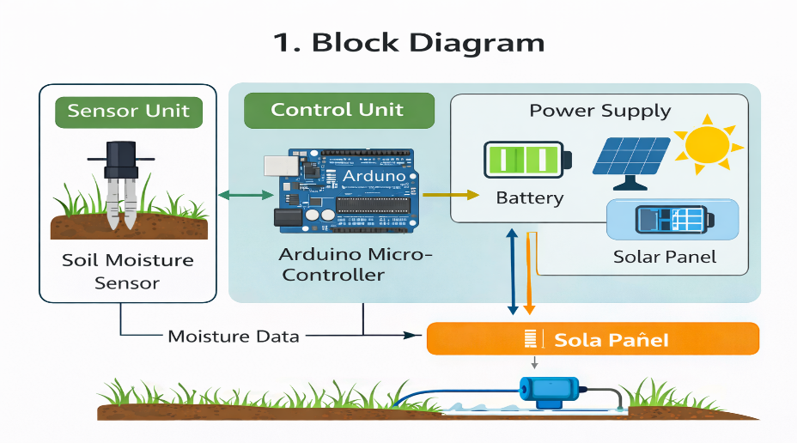
Sequence Diagram – Describes how data flows between sensor, Arduino, Wi-Fi module, and pump.
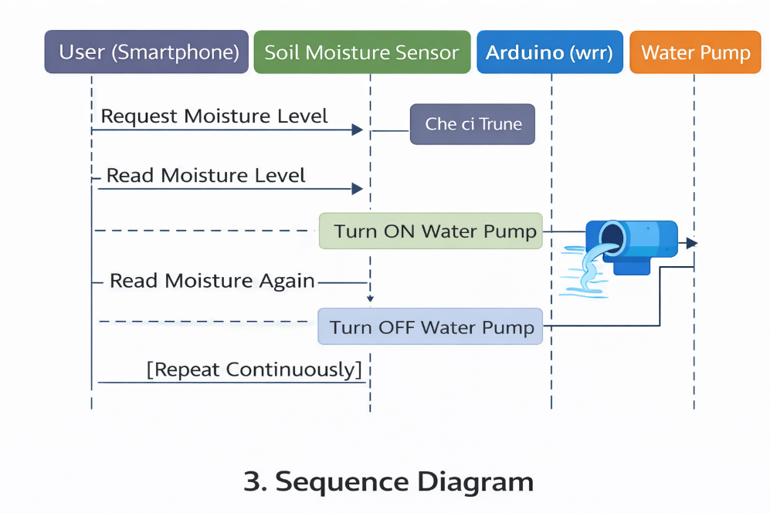
Flowchart – Explains the step-by-step logic of moisture detection and pump control.
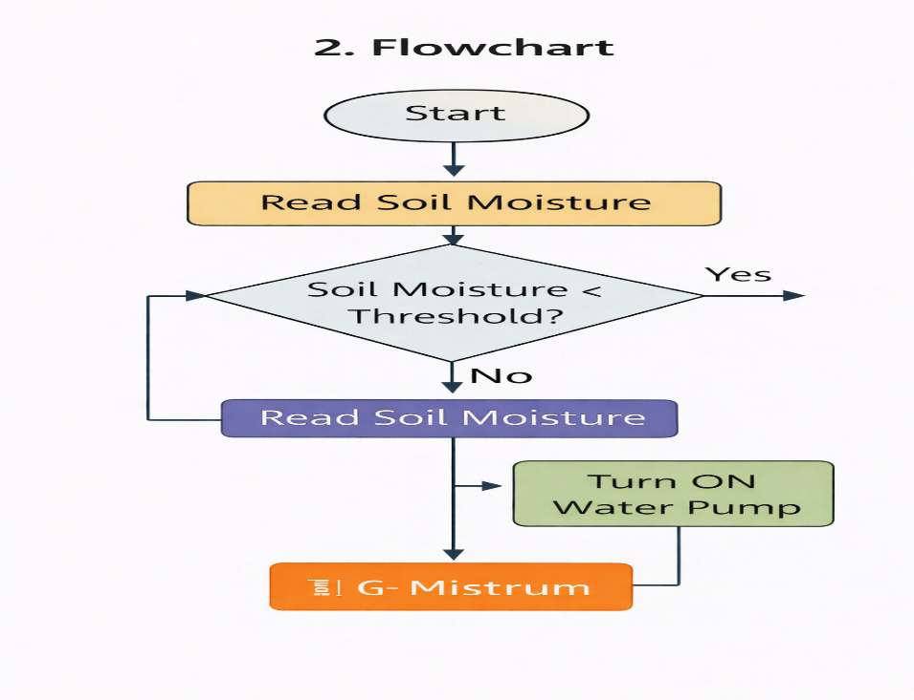
Use Case Diagram – Shows how the farmer interacts with the system.
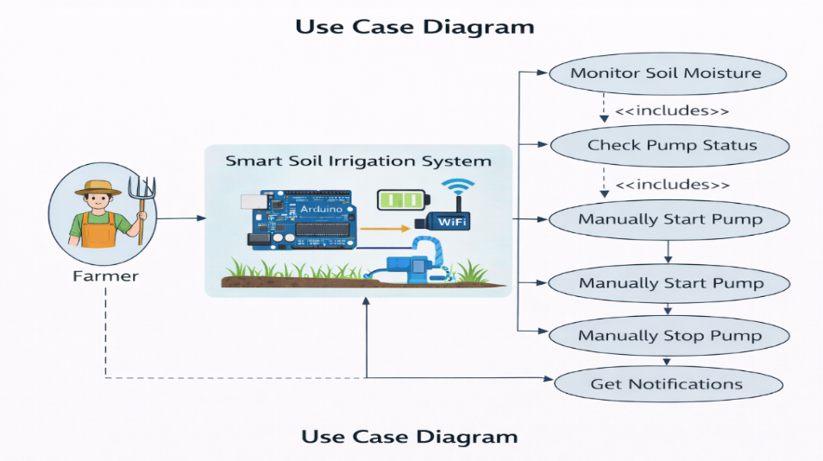
ER Diagram – Describes how system data is structured and related.
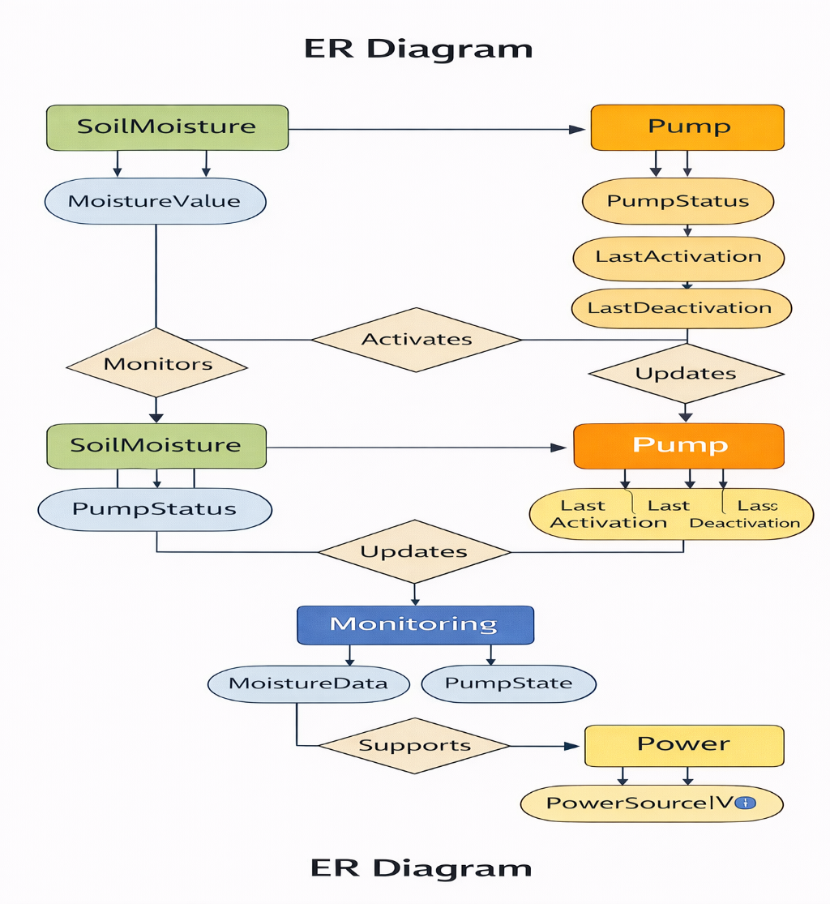

- Data Model Schema
The data model of the Smart Soil Irrigation System defines how sensor readings, pump status, power information, and monitoring data are organized and related. Since this is an IoT-based system, the data is generated in real time and processed by the microcontroller to make irrigation decisions.
  - Sensor Data Model
The Sensor Data Model represents the information collected from the soil moisture sensor. This data is used by the system to determine whether irrigation is required.
Each sensor reading contains:
- Moisture Value – the current water level in the soil
- Timestamp – the time at which the reading was taken
The Arduino continuously reads this data and uses it for decision-making. Accurate sensor data ensures correct irrigation control.
  - Pump Control Model
The Pump Control Model stores information related to the operation of the water pump. It helps the system track when irrigation is active.
This model includes:
- Pump Status – ON or OFF
- Activation Time – when the pump was turned ON
- Deactivation Time – when the pump was turned OFF
The Arduino updates this data whenever the pump state changes.
  - Power Management Model
The Power Management Model represents how the system is powered and monitored.
It includes:
- Power Source – Battery or Solar
- Battery Level – remaining charge
- Solar Charging Status – whether solar panel is charging the battery
This model ensures that the system can manage power efficiently and switch between battery and solar power when needed.
  - Monitoring Data Model
The Monitoring Data Model is used to display system information to the user through the Wi-Fi module.
It contains:
- Current Soil Moisture
- Pump Status
- Power Status
This data is sent to the user so they can remotely observe the condition of the field and the irrigation process.
  - ER Diagram
The Entity Relationship (ER) Diagram shows how the main data entities of the system are related.
The main entities are:
- Soil Moisture
- Pump
- Power
- Monitoring
- The Soil Moisture entity provides data to the Pump entity to decide irrigation.
- The Pump entity updates the Monitoring entity with its current status.
- The Power entity supplies energy to all system components.
The ER diagram visually represents these relationships and helps in understanding the logical structure of the system.
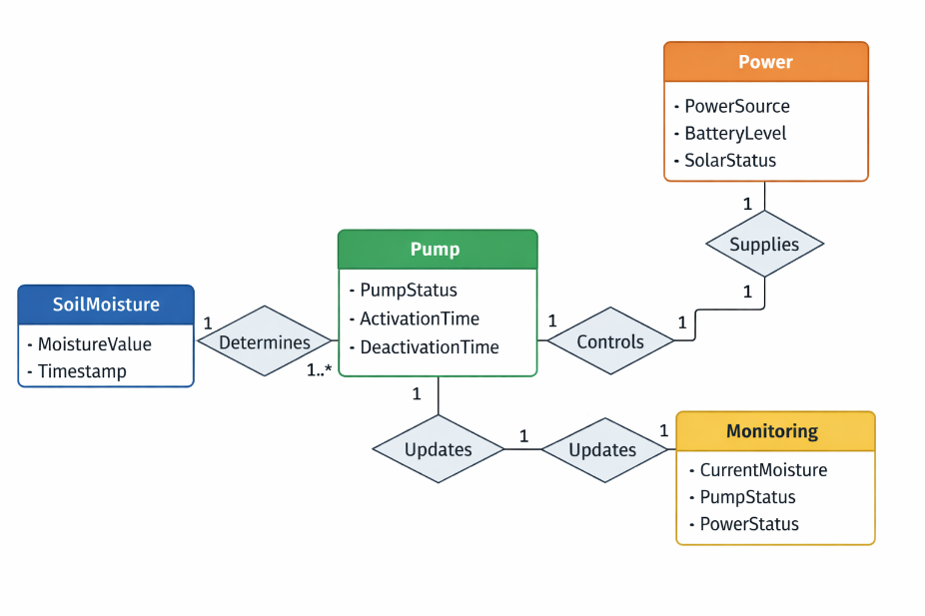
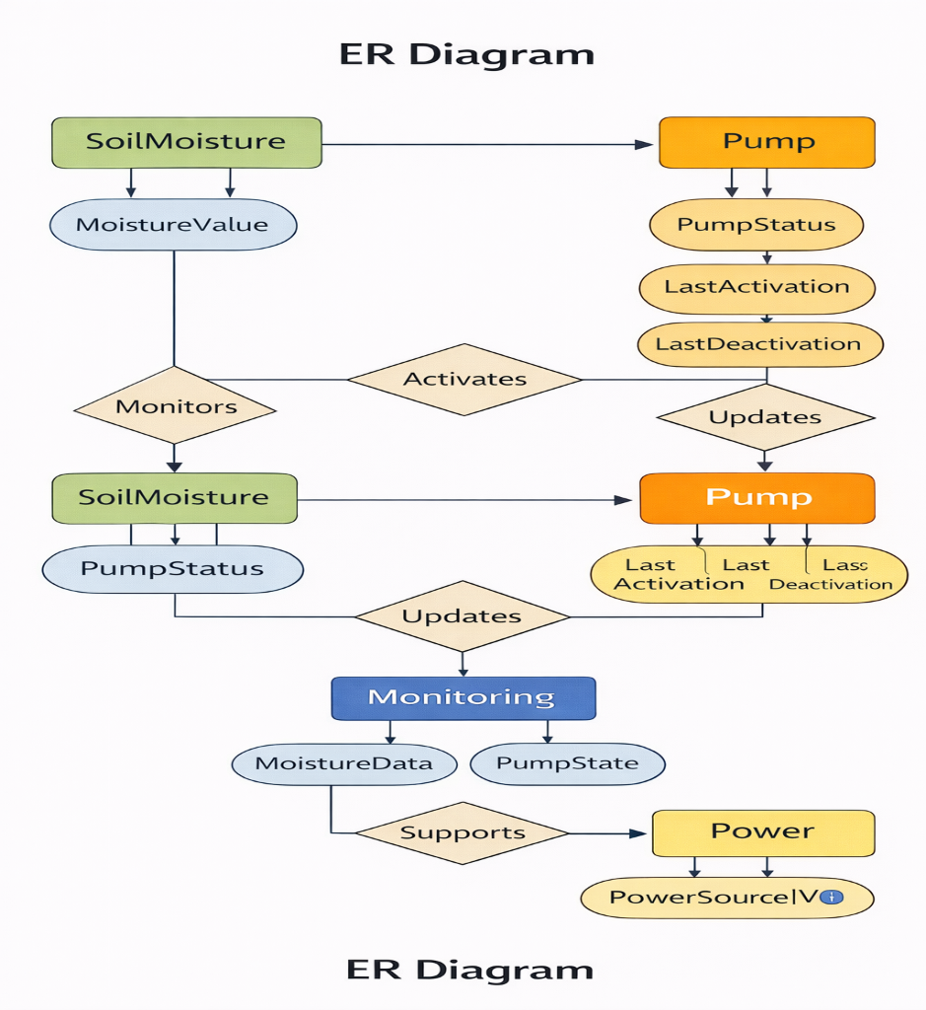

- User Interface
The Smart Soil Irrigation System provides a simple and user-friendly interface that allows the farmer to monitor and control irrigation through an IoT-based platform. The interface is designed to display real-time data from the field and to allow easy understanding of the system status.
  - Design Philosophy
The user interface is designed with simplicity and clarity in mind. Since farmers may not have technical expertise, the interface focuses on displaying essential information in an easy-to-read format. The main goal of the interface is to provide real-time visibility of soil moisture levels, pump status, and power condition.
The design follows a minimal and clean layout so that the user can quickly understand whether the crops need water or not. All-important data is displayed in a visual and readable form to support quick decision-making.
  - Screens and Layout
The user interface consists of two main screens:
Dashboard Screen
This screen shows:
- Current soil moisture level
- Water pump status (ON or OFF)
- Power source (Battery or Solar)
This screen allows the farmer to see the overall condition of the irrigation system at a glance.
System Status Screen
This screen provides:
- Detailed irrigation activity
- Moisture condition of the soil
- Wi-Fi connection status
This screen helps the user understand how the system is performing.
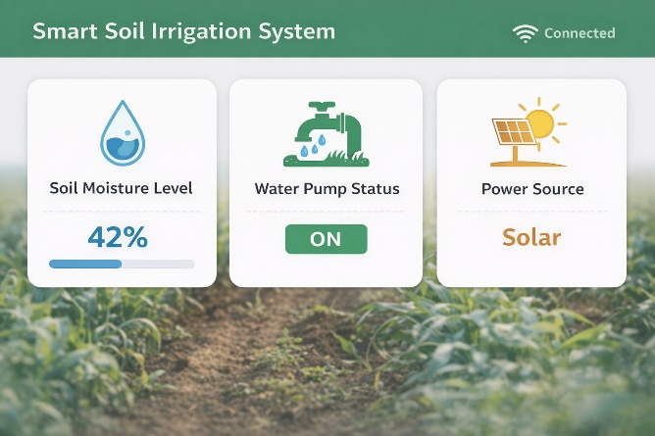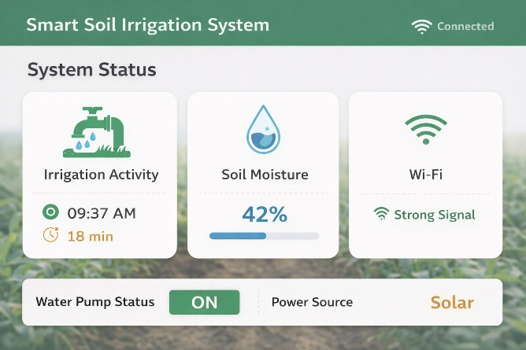
(These are the expected layouts for the current IOT based system.)
  - Controls and Input Constraints
The system does not require manual data input because all values are obtained automatically from sensors. The user interface only provides limited controls such as:
- Viewing soil moisture
- Checking pump status
- Receiving system notifications
Only valid sensor and system data is displayed. Invalid or missing data is ignored to prevent incorrect information from being shown to the user. This ensures that the system remains reliable and easy to use.
- System constraints
The Smart Soil Irrigation System operates under certain technical and environmental limitations that affect its performance.
The system depends on electrical power supplied by a battery and solar panel. If the battery is low and sunlight is not available, the system may temporarily stop functioning. The Wi-Fi module also depends on a stable internet connection for remote monitoring. If network coverage is weak or unavailable, data transmission to the user will not be possible.
The soil moisture sensor may also be affected by environmental conditions such as soil type, temperature, or corrosion, which can influence measurement accuracy. Dust, humidity, and exposure to weather may impact electronic components if not properly protected.
- Assumptions and Dependencies
The Smart Soil Irrigation System is designed based on the following assumptions:
- The soil moisture sensor is correctly placed in the soil near the plant roots.
The water pump is properly connected to a water source.
- The Arduino microcontroller and Wi-Fi module are configured correctly.
- The battery and solar panel are functioning properly.
The system depends on the soil moisture sensor to provide accurate readings. It also depends on the relay and water pump to supply water when required. The Wi-Fi network is required for remote monitoring, and sufficient power is required for continuous operation.
If any of these assumptions or dependencies are not met, the system may not operate as expected.
- Error Handling and Fault Management
The Smart Soil Irrigation System is designed to handle possible failures to maintain reliable operation.
If the soil moisture sensor fails or provides invalid data, the Arduino ignores incorrect readings and prevents the pump from turning on to avoid over-watering. The system continues checking until valid sensor data is received.
If the Wi-Fi connection is lost, remote monitoring will stop, but the automatic irrigation process continues locally. Once the connection is restored, data transmission resumes.
If power drops due to a low battery or lack of solar energy, the system shuts down safely to prevent hardware damage. When power becomes available again, the system restarts and continues normal operation.
This error-handling approach ensures that the system remains safe, reliable, and efficient.
- Security Design
Security is important in an IoT-based system because data and control commands are transmitted wirelessly. The Smart Soil Irrigation System uses the Wi-Fi module to send soil moisture readings and pump status to the user. This data is sent over a secured network so that unauthorized users cannot easily access it.
Only the authorized farmer is allowed to monitor the system and receive updates. The system does not accept commands from unknown devices, which prevents misuse or unauthorized control of the water pump. The Arduino also validates all incoming data from the Wi-Fi module before performing any action.
This security design ensures that irrigation data remains private and the system cannot be controlled by unauthorized users.
- Deployment Architecture & Future Scalability
The Smart Soil Irrigation System is deployed directly in the agricultural field. The soil moisture sensor is installed in the soil near the crop roots to measure accurate moisture levels. The Arduino microcontroller, Wi-Fi module, and relay are placed inside a protective enclosure to prevent damage from dust, rain, and sunlight.
The water pump is installed near the water source and connected to irrigation pipes. It is controlled by the Arduino through the relay. The battery and solar panel are placed close to the control unit. The solar panel is positioned in an open area to receive maximum sunlight and charge the battery.
This deployment setup allows the system to operate efficiently in outdoor farming environments.
FUTURE SCALABILITY:
The Smart Soil Irrigation System is designed so that it can be expanded for larger agricultural areas. Additional soil moisture sensors can be installed in different parts of the field to monitor moisture in multiple zones.
Multiple water pumps can also be added so that different areas of the farm can be irrigated independently. The system can be upgraded with more powerful microcontrollers and better communication modules to support large farms and advanced monitoring features.
This scalability makes the system suitable for both small gardens and large agricultural fields.

